Deep Learning

Table of Contents

Neural network 1

Neural network intuition 1

Neural Network Model 3

TensorFlow Implementation 4

Neural network implementation in Python 7

Neural network training 8

Training Steps 8

Activation function 11

Multi-class classification 12

Multi-label classification 15

Adam optimizer 16

Additional layer types 18

Backward propagation 19

# Neural network

## Neural network intuition

The reason that the deep learning takes off these years: increase of data & improvement of computer processors

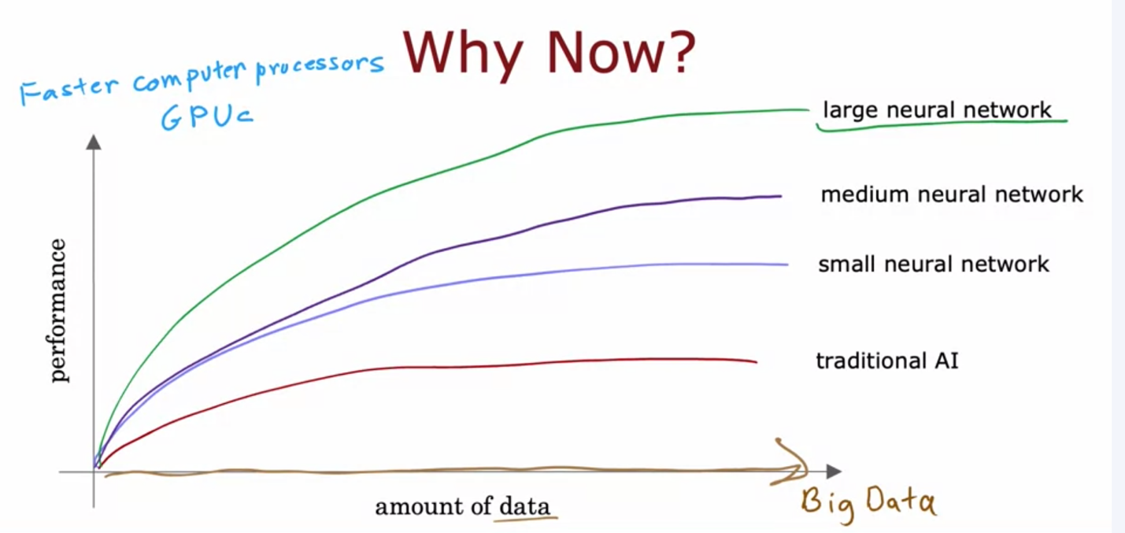

Example 1 of neural network:

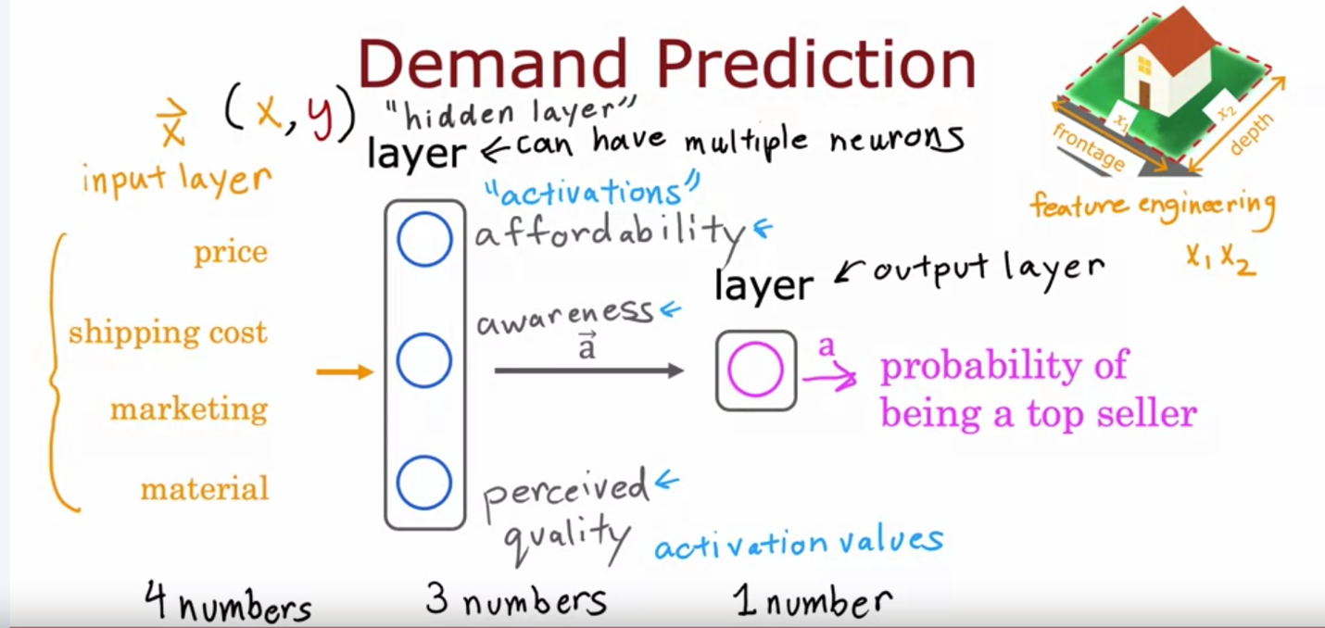

Example 2 of neural network:

The neurons in the first hidden layer are shown looking at relatively small windows to look for these edges. In the second hidden layer is looking at bigger window, and the third hidden layer is looking at even bigger window. These little neurons visualizations actually correspond to differently sized regions in the image.

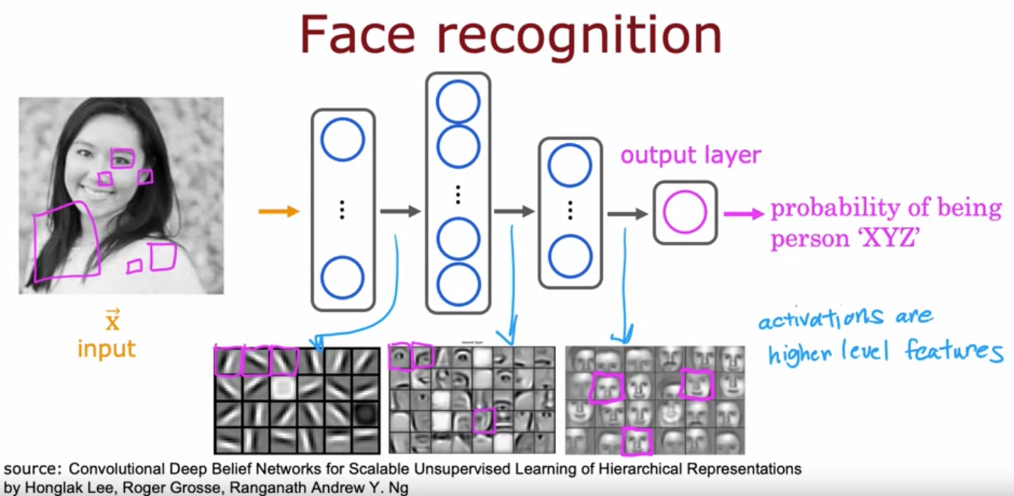

## Neural Network Model

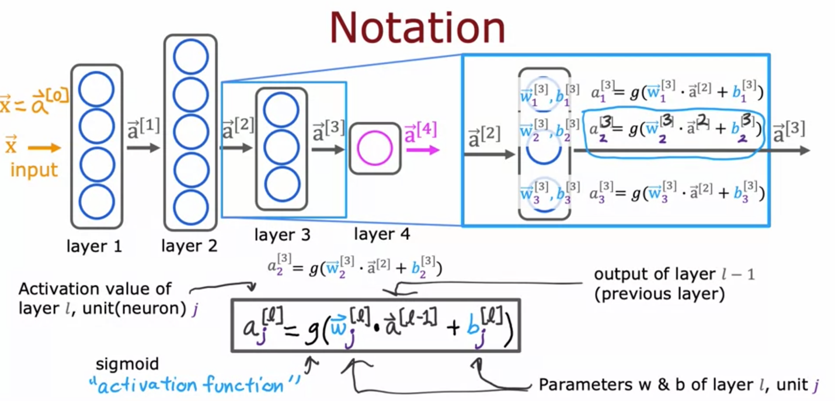

## TensorFlow Implementation

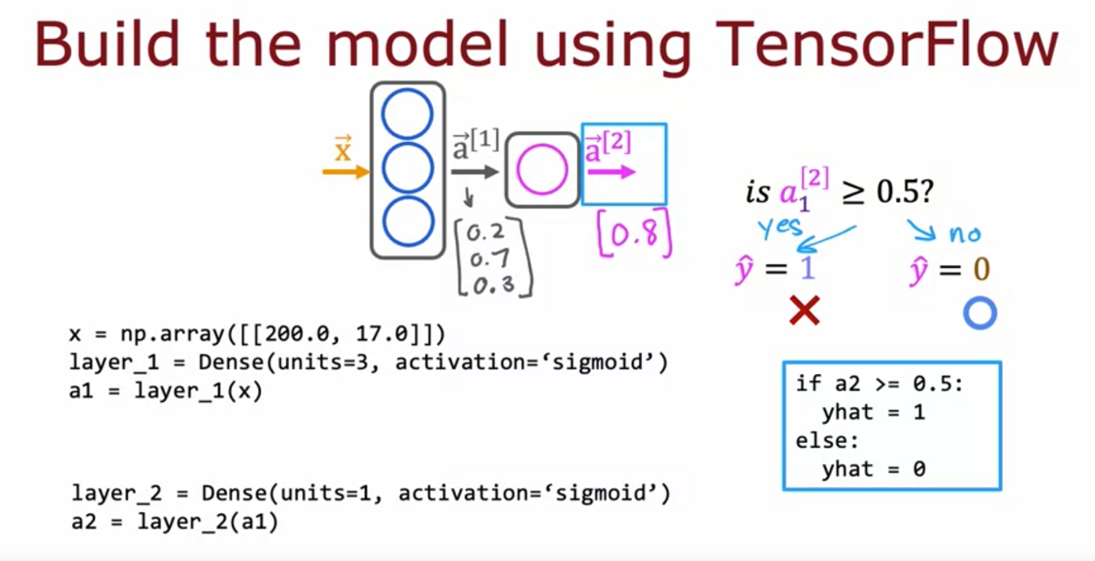

With TensorFlow the convention is to use matrices to represent the data 🡪 matrix uses two brackets and vector uses 1 bracket

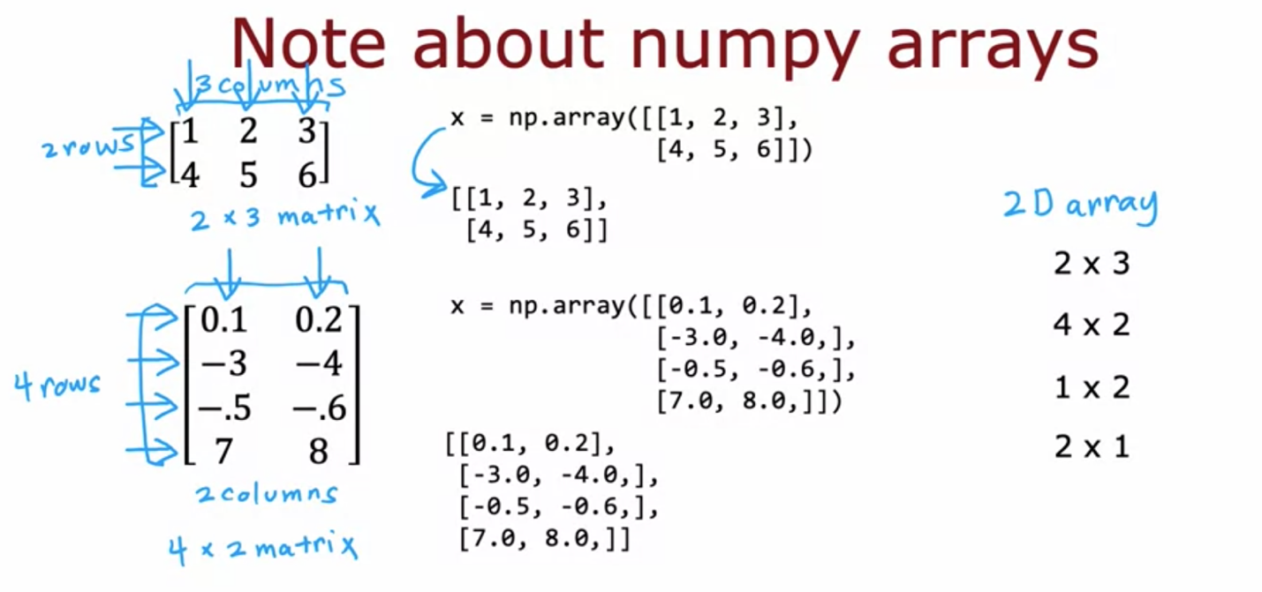

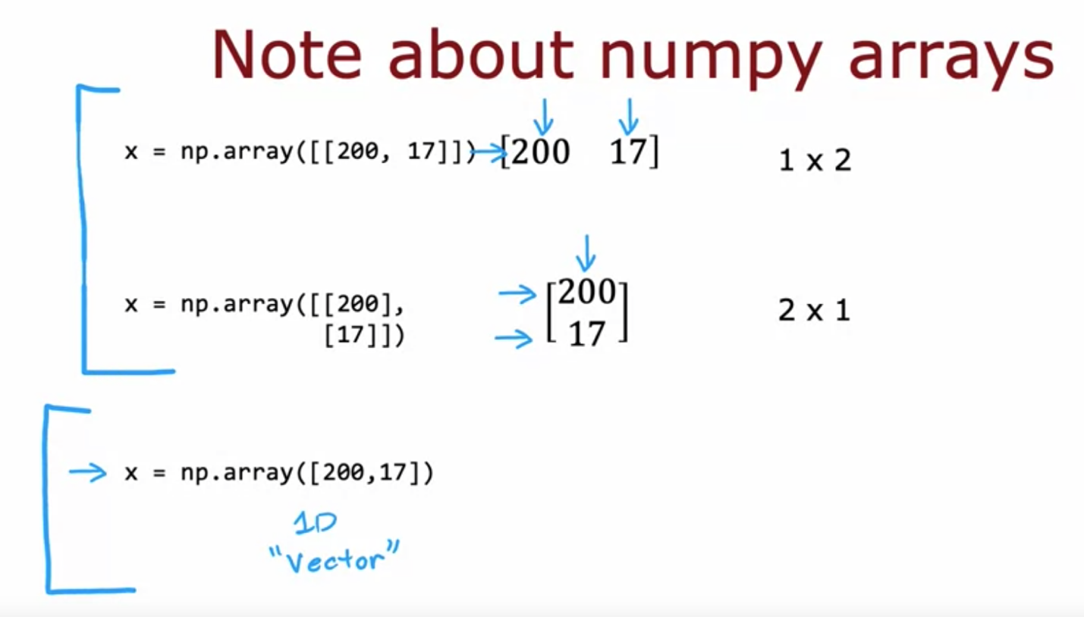

Layer 1 is a dense layer with 3 neurons(units) 🡪 the output of layer 1 is a matrix (represented by tensor) with 1*3 dimension 🡪 using .numpy can convert tensor to a numpy array.

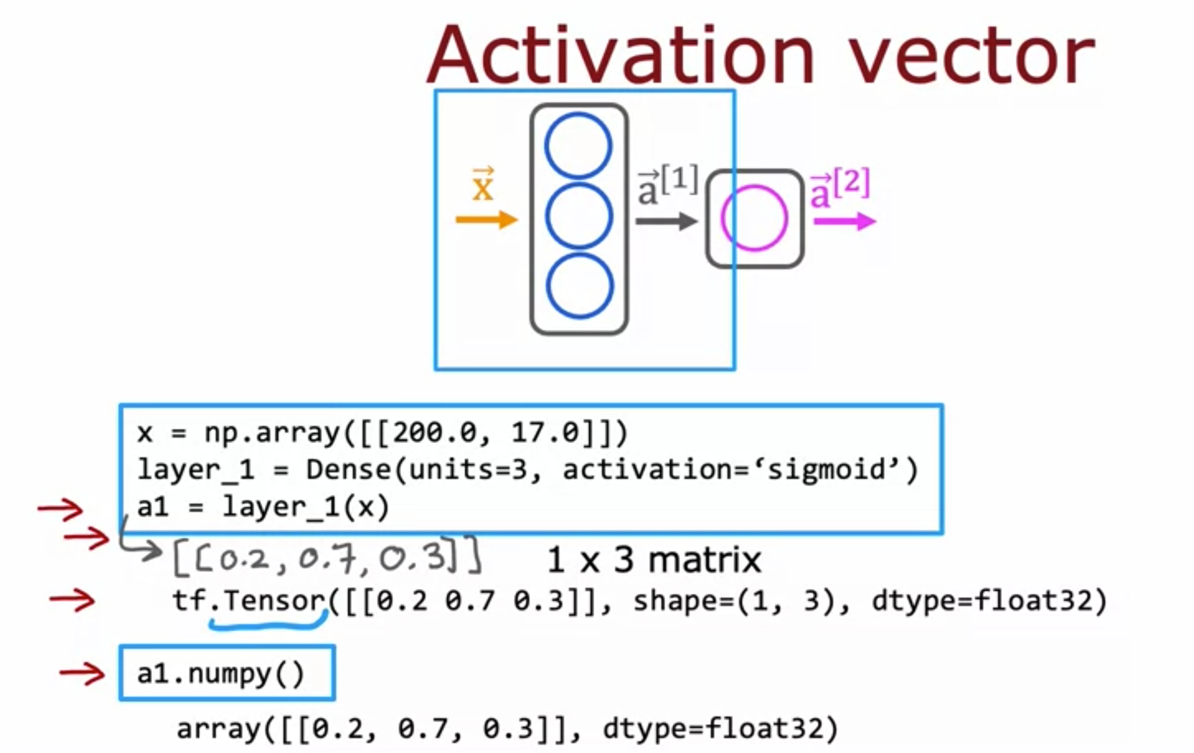

Use sequential function to tell the structure

Example 1:

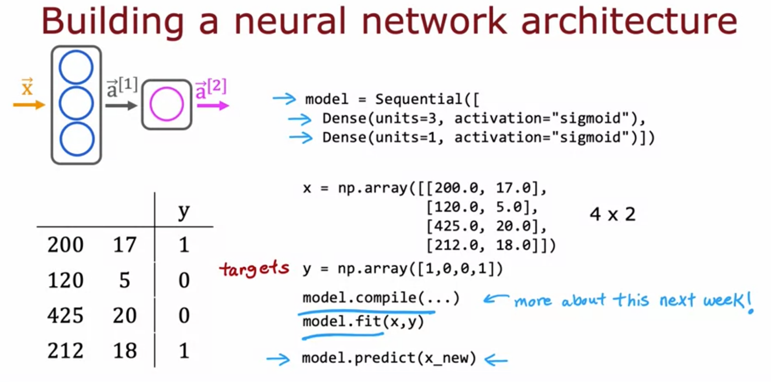

Example 2:

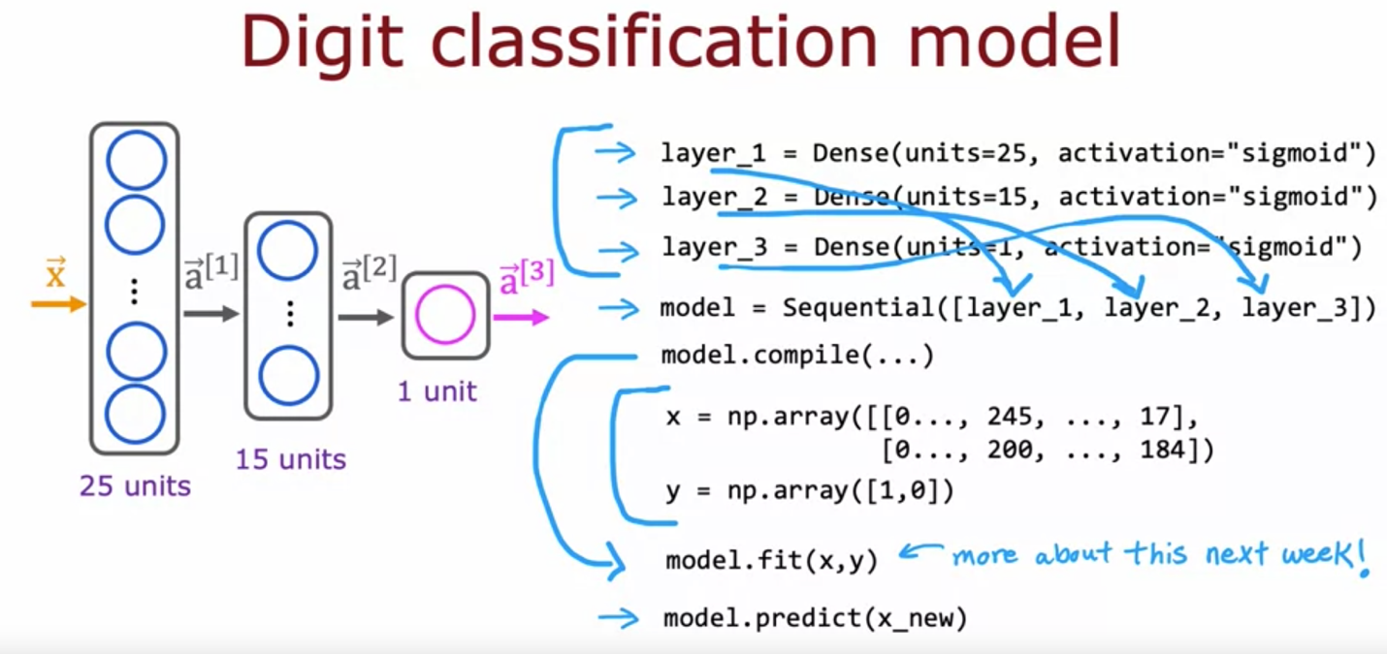

## Neural network implementation in Python

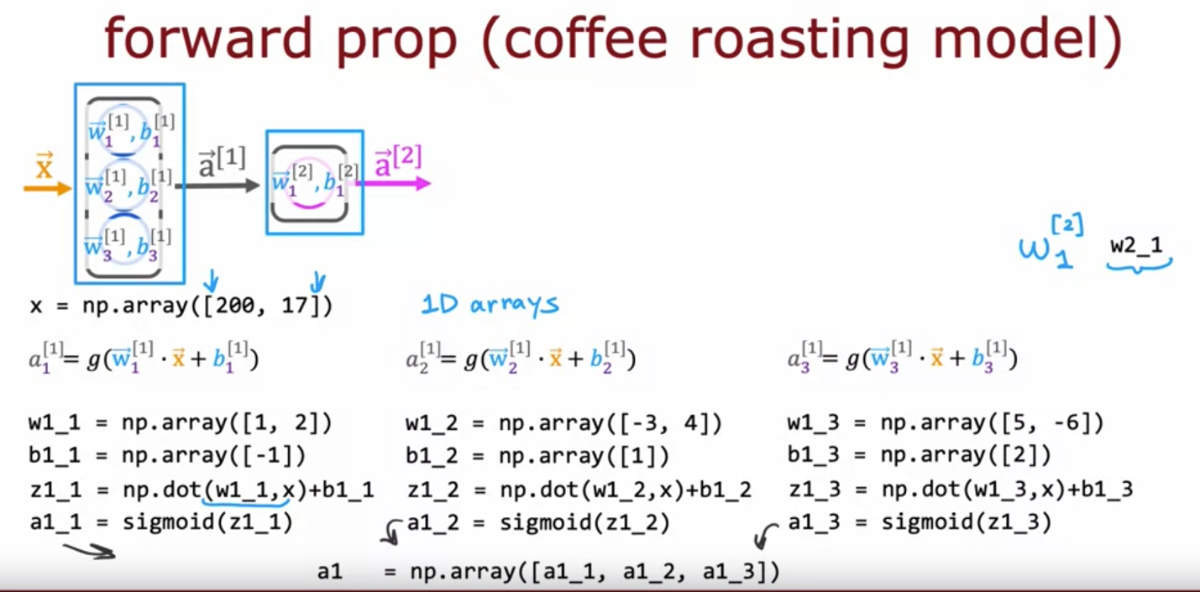

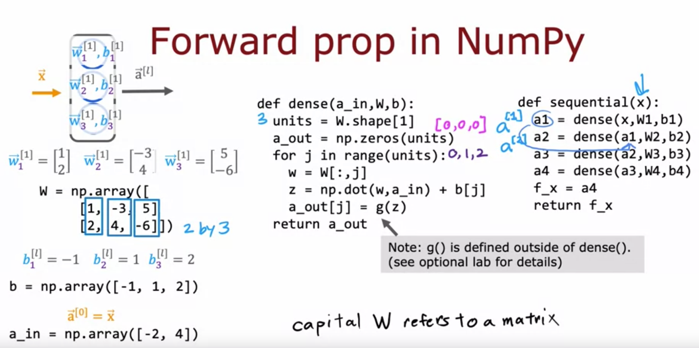

Vectorize the process:

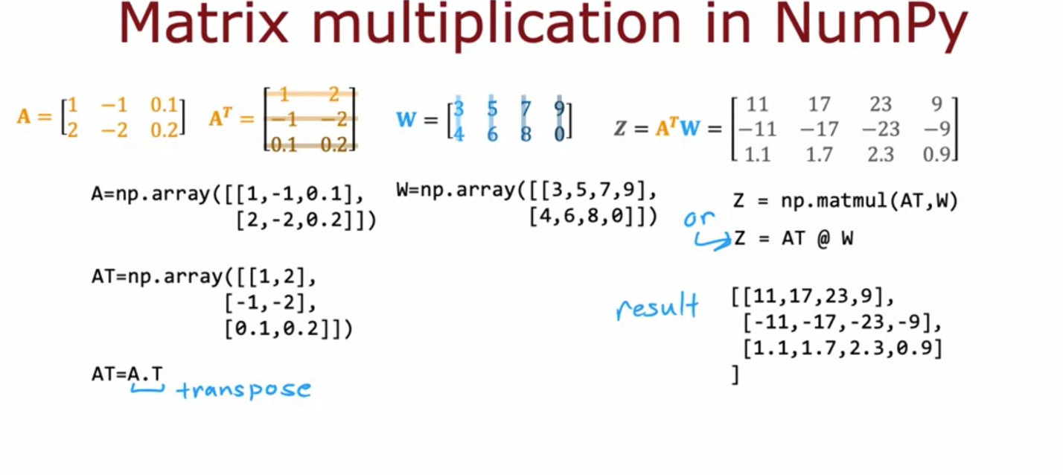

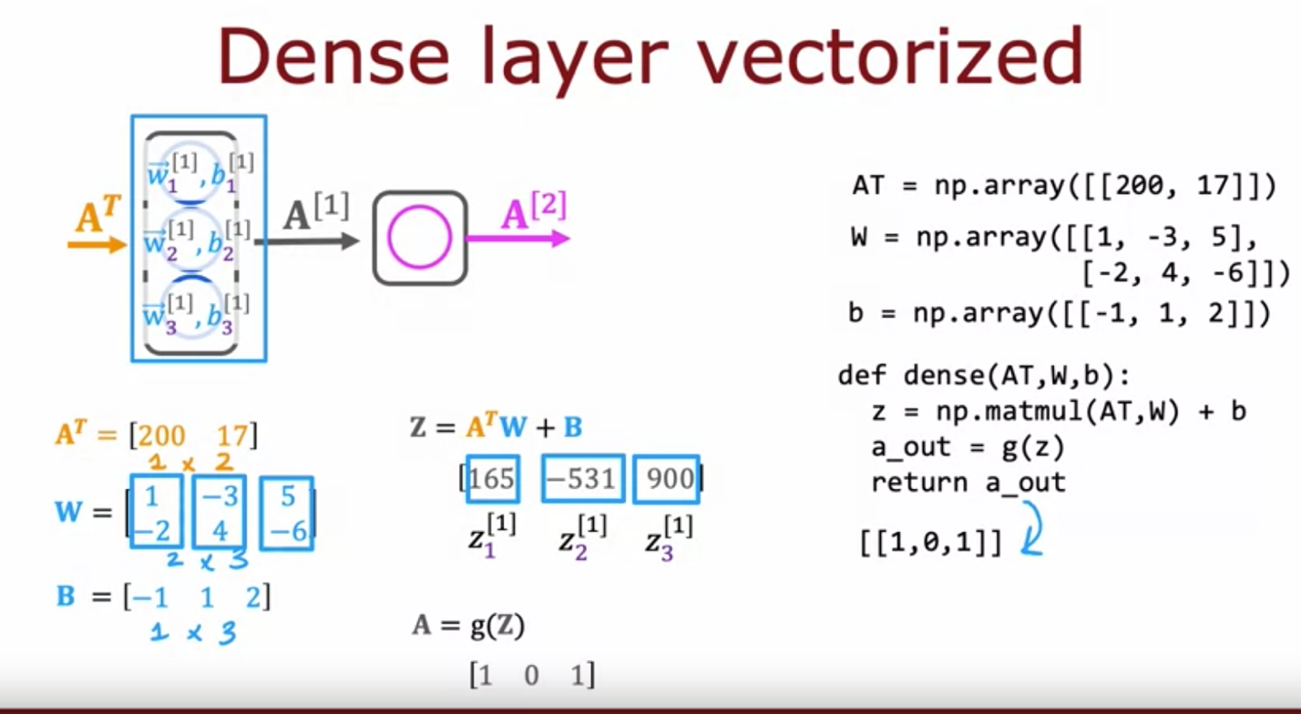

# Neural network training

## Training Steps

Training steps: Step 1 is to specify the model, which tells TensorFlow how to compute for the inference. Step 2 compiles the model using a specific loss function, and Step 3 is to train the model.

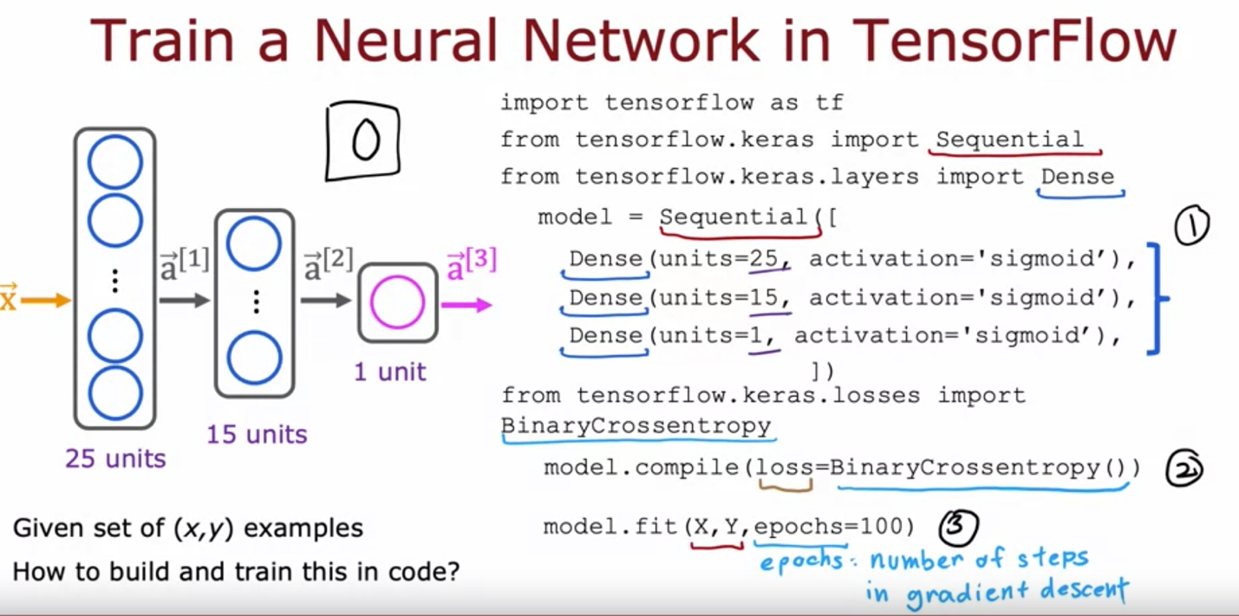

Training steps comparison between logistic regression and neural network:

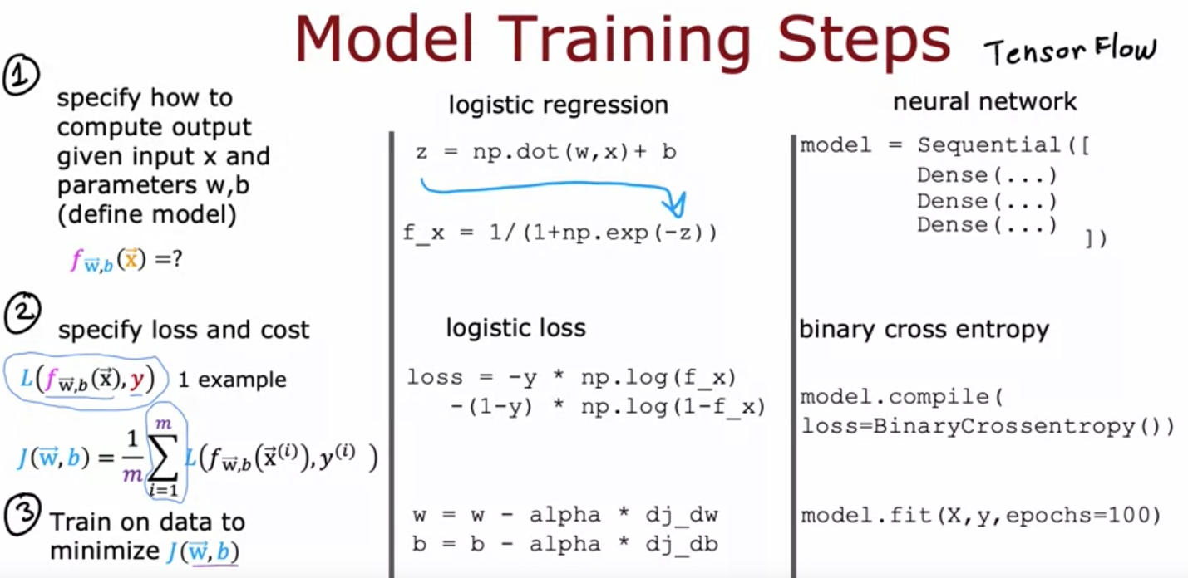

Step 1:

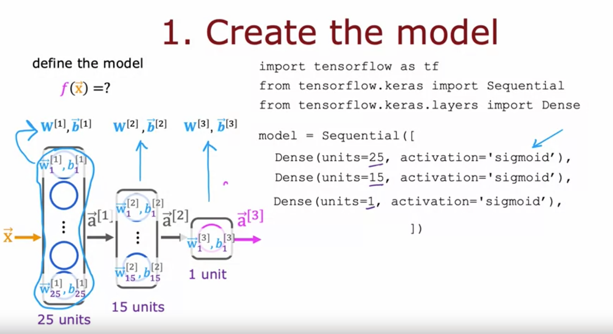

Step 2: for binary classification we can use binary cross entropy as the loss function. For regression problems, we can use MSE.

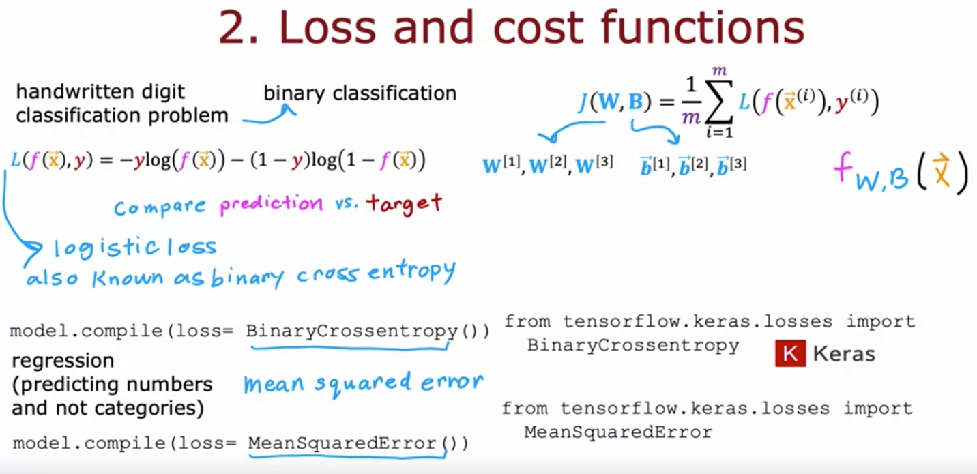

Step 3:

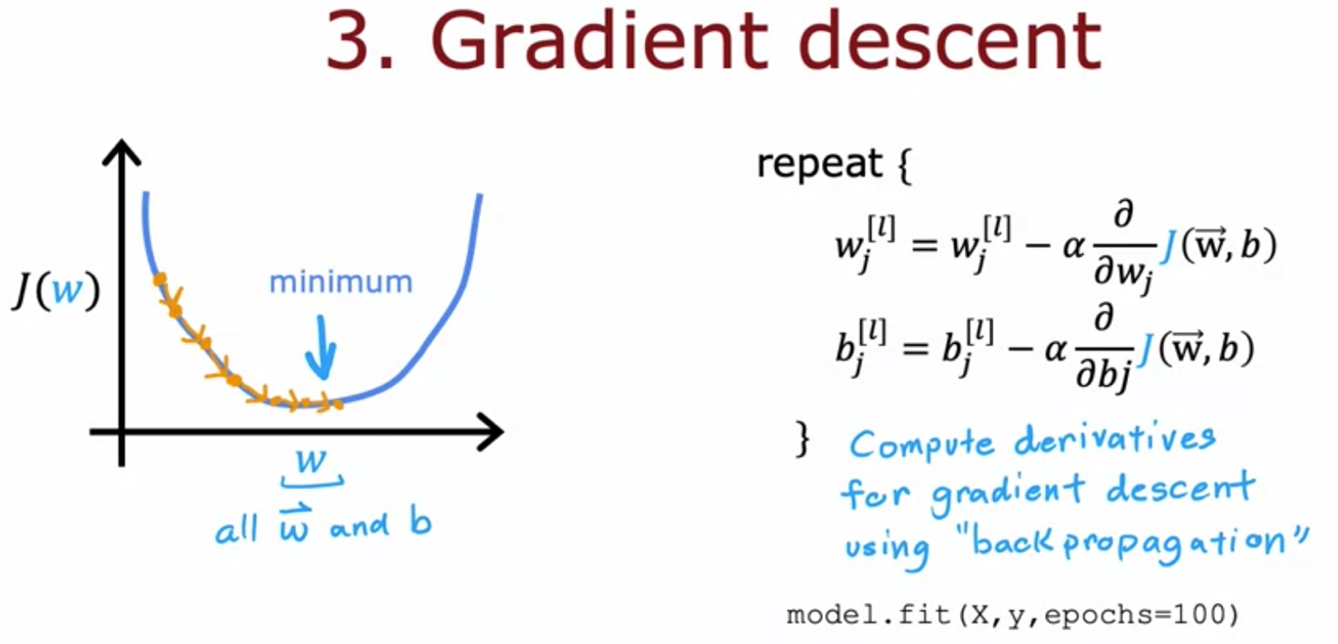

## Activation function

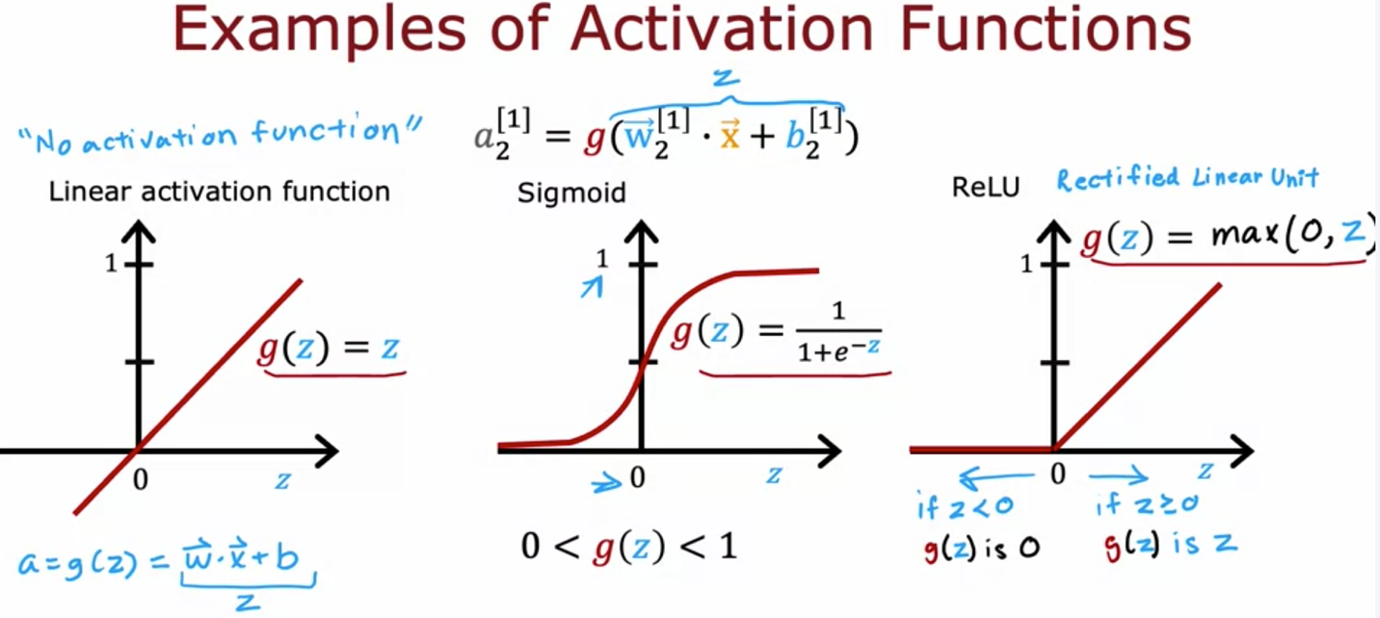

Choice of activation function for the output layer depends on the target label or the ground truth label y:

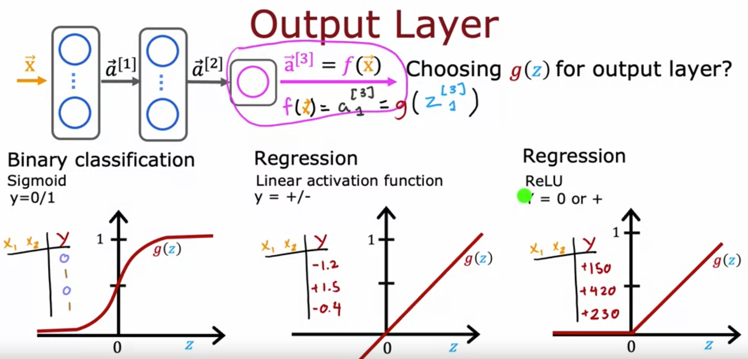

For the hidden layers, ReLU is the most commonly used function coz it only has one flat part, leading to a faster learning using gradient descent. Also, using linear activation functions in the hidden layer is useless

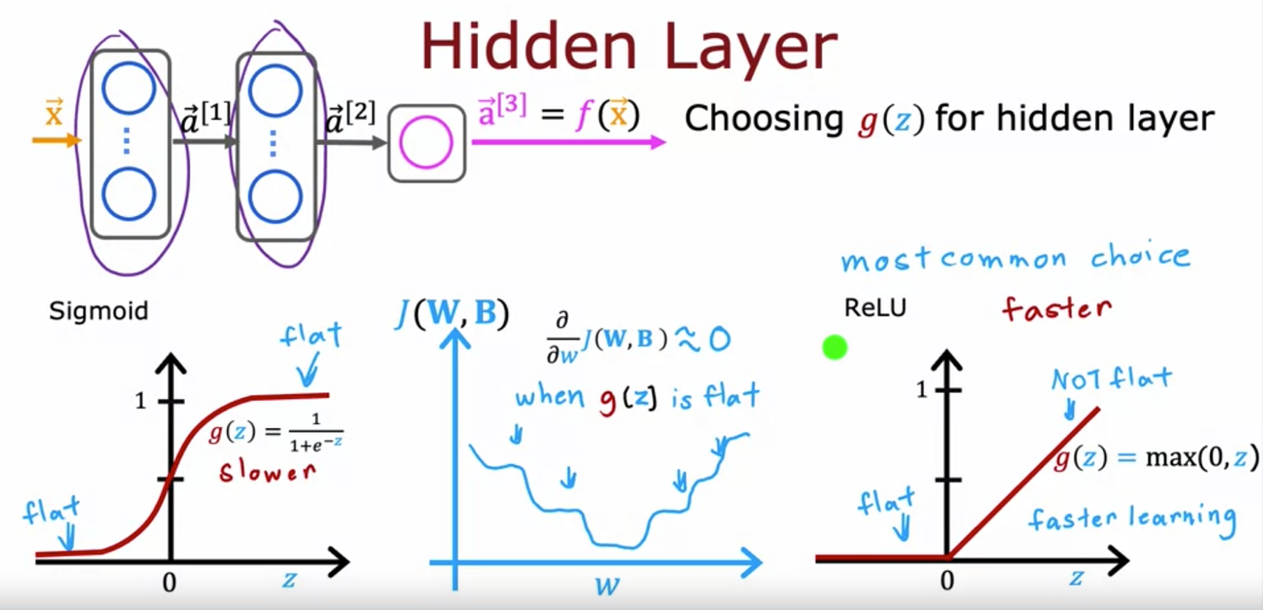

## Multi-class classification

Softmax regression:

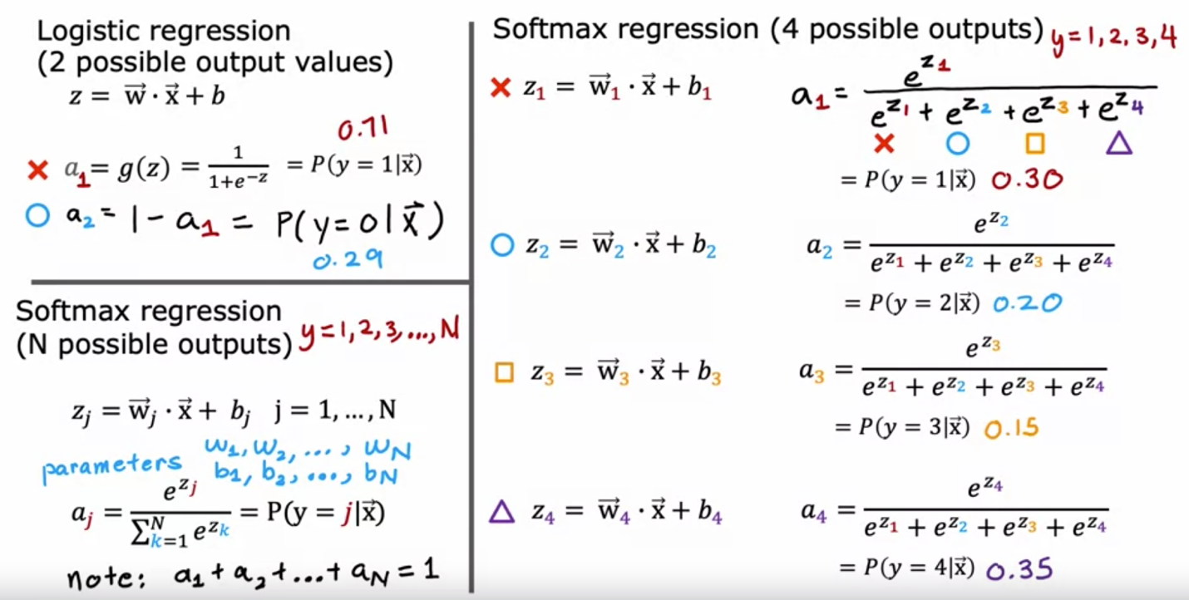

Cost function of softmax regression:

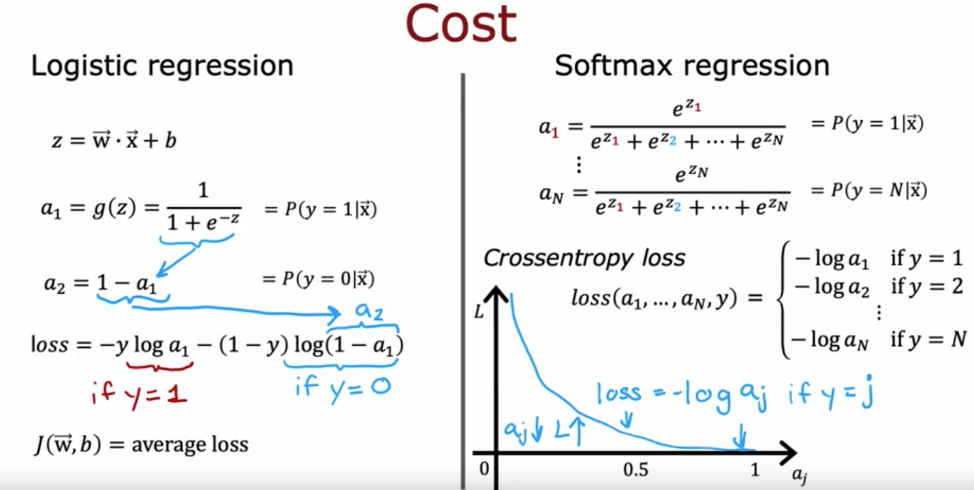

When using softmax as the activation function, a_i requires the input of z1, …, z_n. But for other activation functions, a_i only requires the input of z_i.

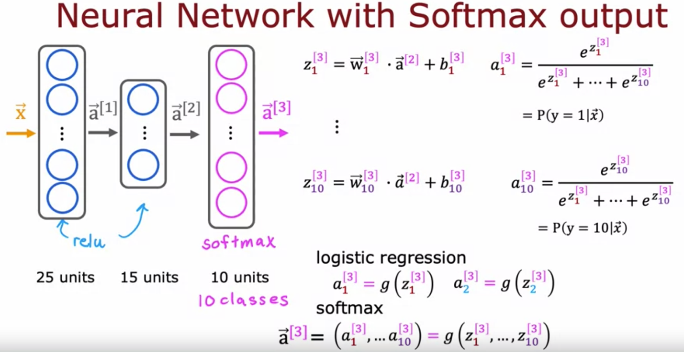

More numerically accurate implementation of logistic loss:

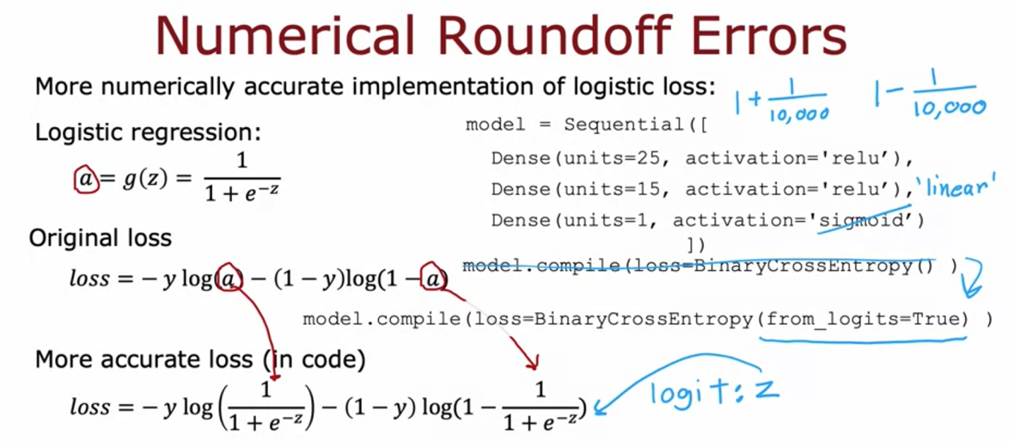

More numerically accurate implementation of softmax loss:

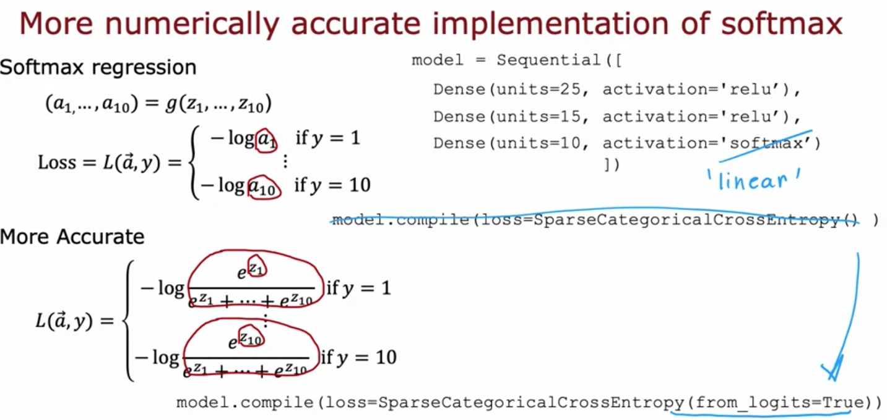

When using from_logits=True, the output is z instead of a. therefore, we need to convert the output to a but using tf.nn.softmax(logits) or tf.nn.sigmoid(logits) depending on whether it is multiclass/binary classification problem:

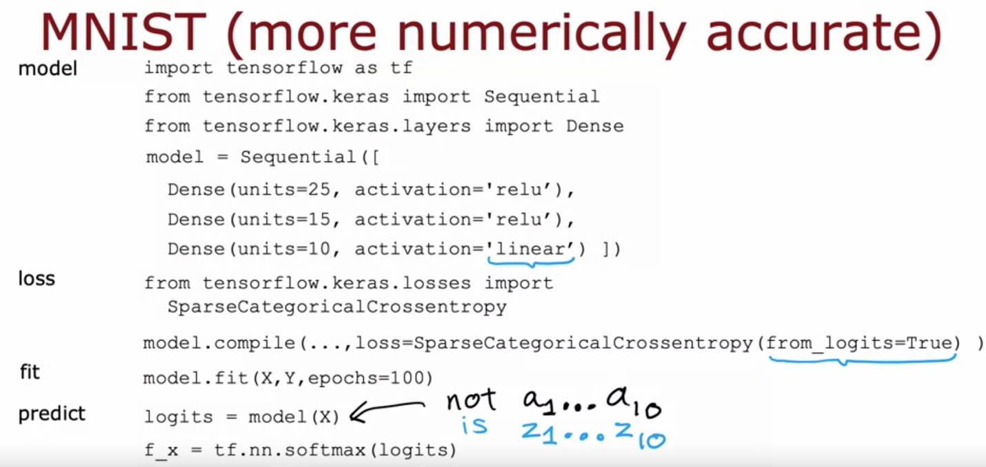

## Multi-label classification

Definition: Target Y is a vector instead of a single number

Example:

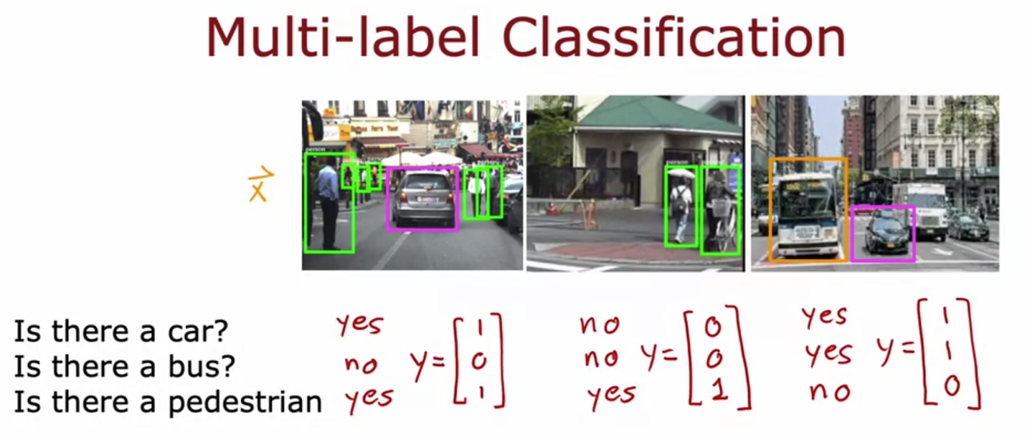

Multi-label classification can be solved using neural network with the output layer having multiple units:

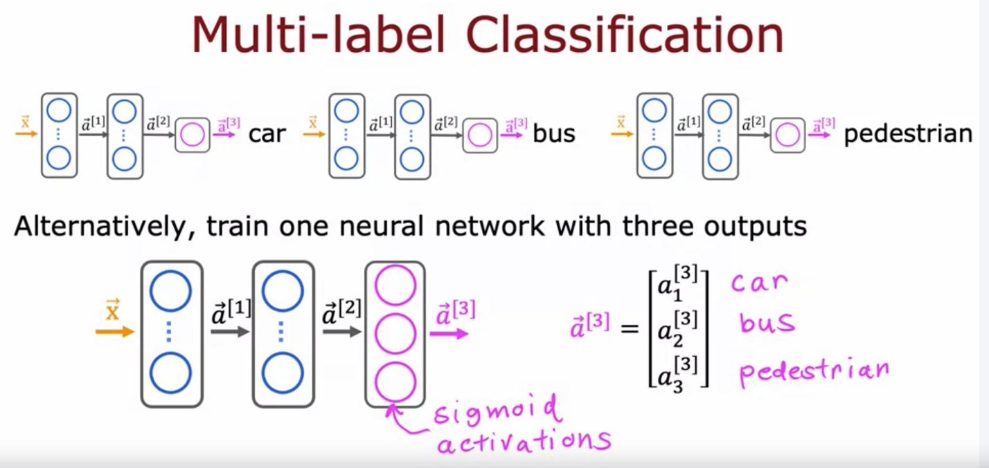

## Adam optimizer

For gradient descent, can we have an algorithm to automatically increase Alpha? They just make it take bigger steps and get to the minimum faster 🡪 Adam algorithm can adjust the learning rate automatically.

The Adam algorithm doesn't use a single global learning rate Alpha. It uses a different learning rate for every single parameter of your model. Adam uses the mean (first moment: How consistently is the slope pointing this way?) of recent gradients to decide direction, and the mean of squared gradients (second moment: How big or noisy are the gradients?) to decide step size.

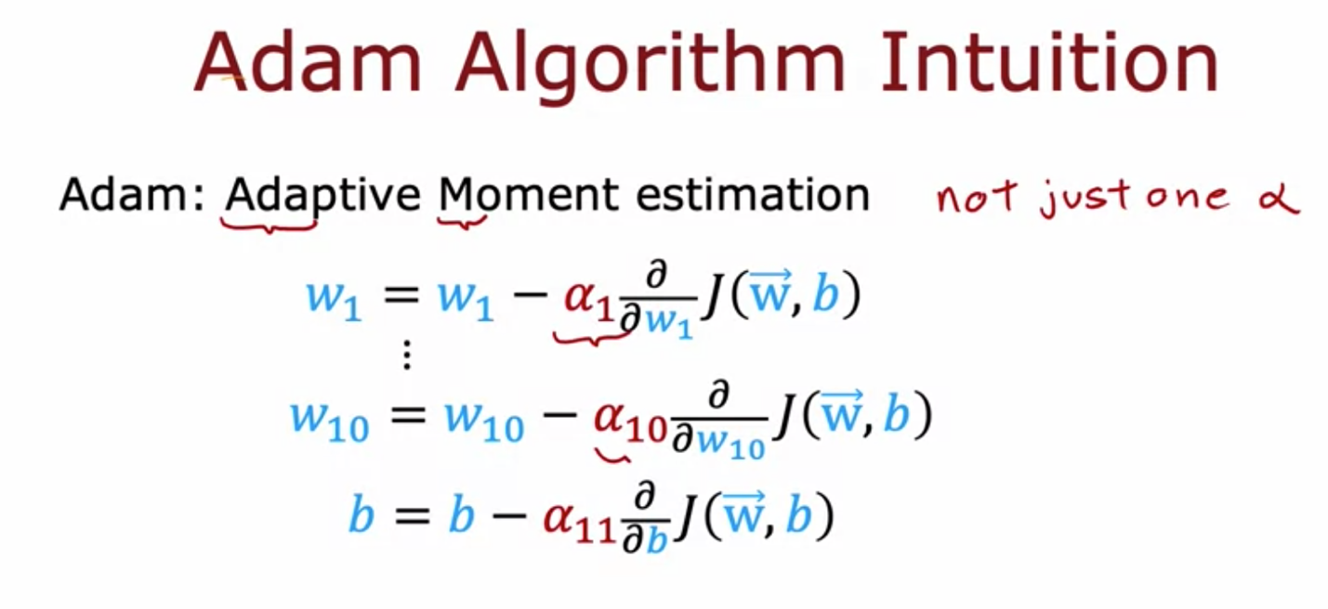

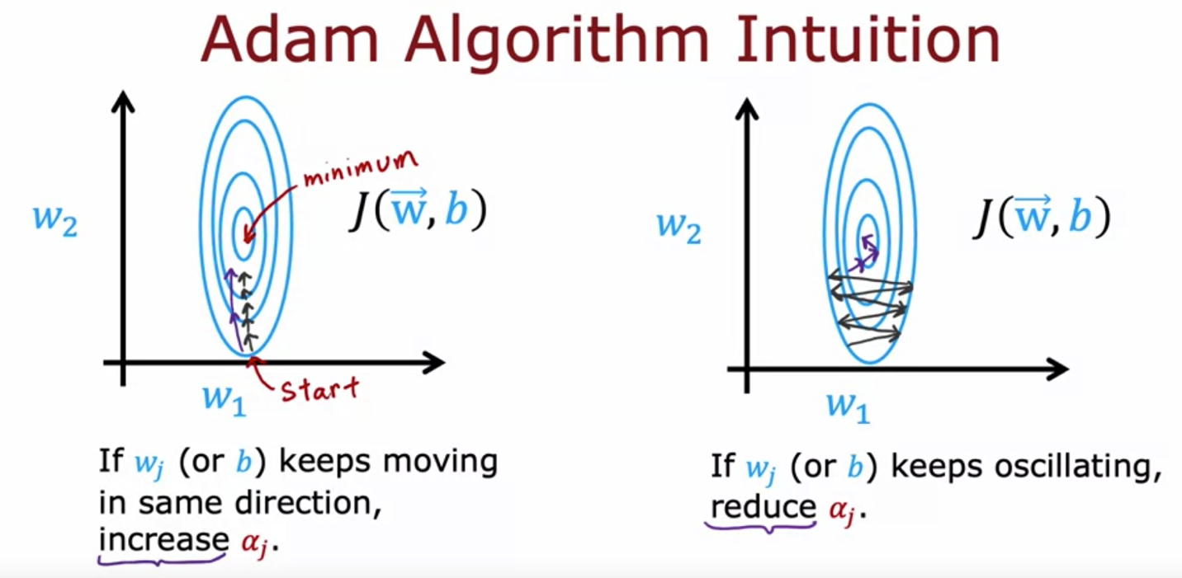

Python Implementation of Adam:

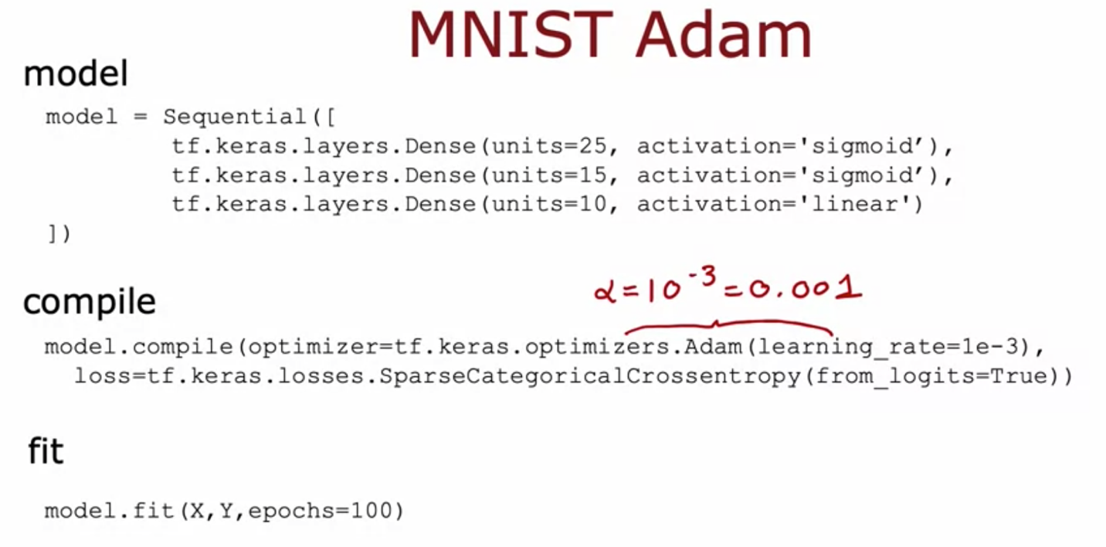

## Additional layer types

Convolutional layer: each neuron only look at some of the pixels instead of all pixels. Advantage: 1) it speeds up the computation and 2) it needs less training data 🡪 less prone to overfitting

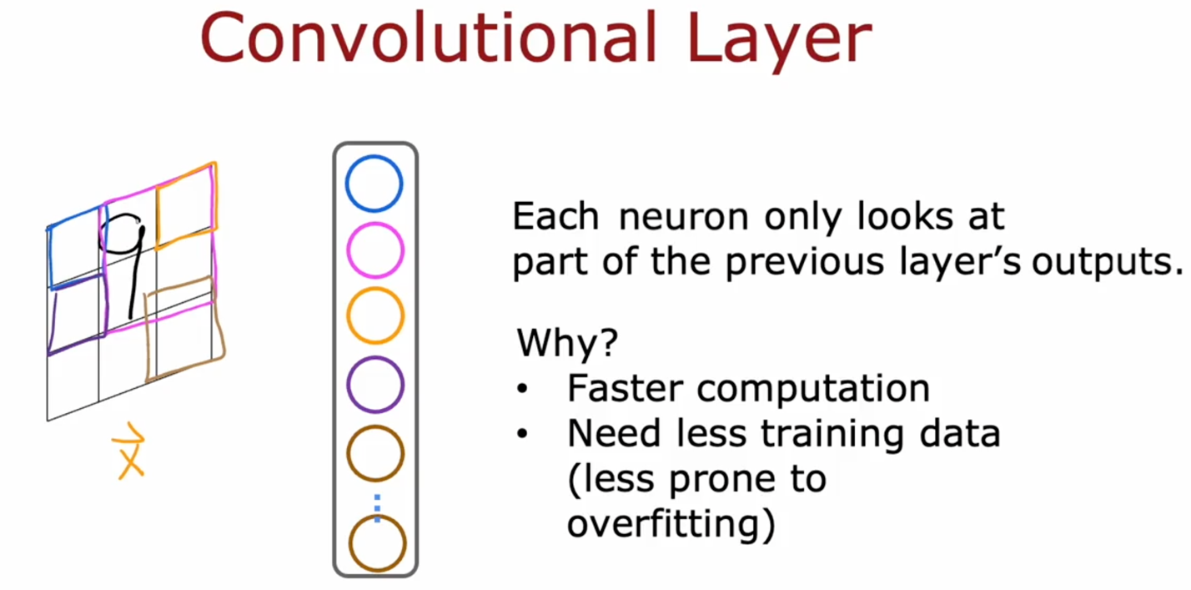

With convolutional layers you have many architecture choices such as 1) how big is the window of inputs that a single neuron should look at and 2) how many neurons should layer have. And by choosing those architectural parameters effectively, you can build new versions of neural networks that can be even more effective than the dense layer for some applications.

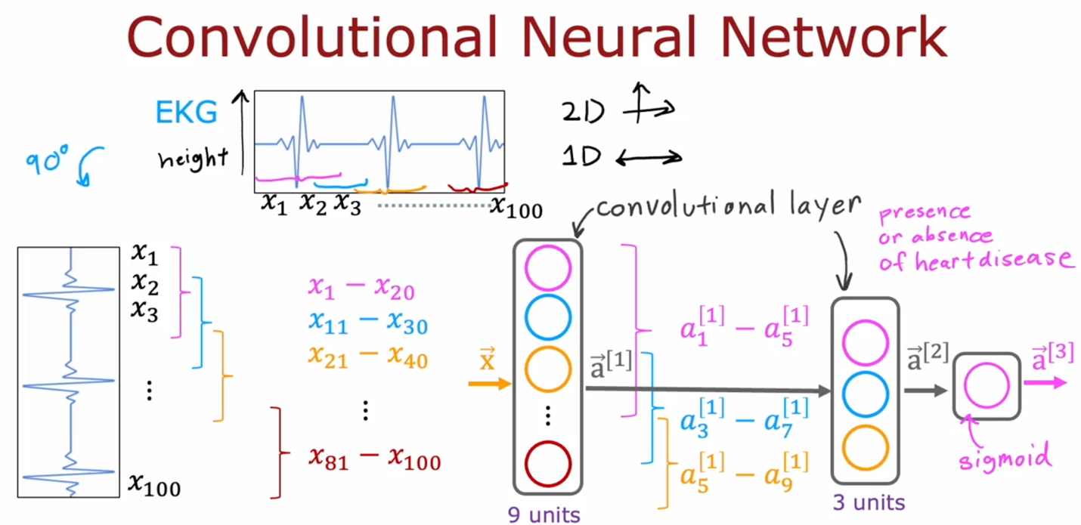

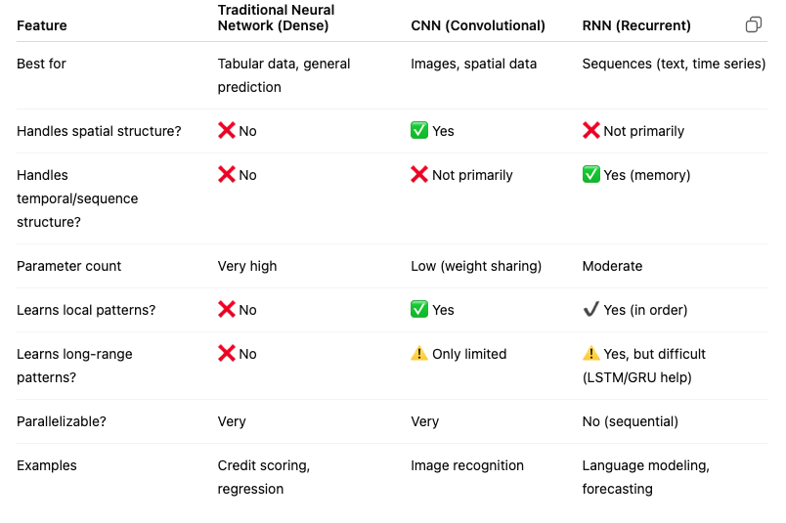

## Backward propagation

Forward prop: get the function of J. Backward: get the derivative to minimize J. Gradient descent requires the derivative of the cost with respect to each parameter in the network. This cycle (forward propagation, error calculation, backpropagation, and weights & biases update) is repeated for many iterations (or epochs) during the training process, gradually improving the accuracy of the network’s predictions.

